
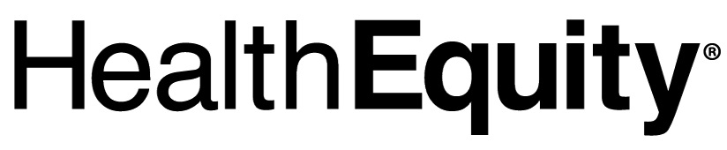

15 West Scenic Pointe Drive, Suite 100
Draper, UT 84020
«First_Name» «Last_Name»
«Street1»
«Street2»
«City», «State» «Zip»

December 2, 2021

Dear «First_Name»,

We are following up regarding the recent communication you received about the transition of your Health Savings Accounts (HSAs) from UMB to HealthEquity. You have been identified as having an HSA with UMB as the custodian, and already having or had an HSA with HealthEquity. As part of the transition to HealthEquity, your accounts will be consolidated into your existing HSA at HealthEquity and HealthEquity will use the most current information we have for your HSA.

In addition, the change may require you to update your HealthEquity beneficiary designation since UMB HSA beneficiary information is not being transferred by UMB. When you log in to the HealthEquity portal after the transition of your UMB HSA is complete on December 16, 2021, we encourage you to review your HealthEquity account to ensure the migrated information is accurate and to update the beneficiary designation for your HSA.

Will I receive a new HealthEquity® Visa® Health Account Card¹?
If you have an open HSA at HealthEquity with an active HSA debit card, your existing card will continue to work and you will not receive a new HSA debit card.

If your HealthEquity HSA was closed, your account will be reopened and you should have received a new HSA debit card in the mail the week of November 29, 2021.

How do I order a replacement HSA debit card or additional cards for my dependents?
You may order a replacement HSA debit card or additional cards for your dependents by logging into HealthEquity member portal or by contacting Member Services at 844.355.0150.

Are there any tax consequences as a result of the merging of my accounts?
No. While HSAs are tax-advantaged accounts,² there should be no tax implications due to the merging of your accounts.

Will my transaction history be transferred to HealthEquity?
Your 2021 transaction history will be imported into the HealthEquity system within a couple of weeks following the December 16 conversion. For the years prior to the 2021 tax year, we encourage you to download any account history information for your WageWorks HSA before December 7, 2021.

Who will send me tax statements?
UMB will provide the 2021 tax reporting information for any activity incurred prior to the conversion. HealthEquity will provide the 2021 tax reporting information for any activity incurred after the conversion.

If you have any questions about your account, please call HealthEquity Member Services, available 24/7 at 844.355.0150.

Thank you,

HealthEquity Member Services

1 This card is issued by The Bancorp Bank; member FDIC pursuant to a license from Visa U.S.A. Inc. Your card can be used everywhere Visa debit cards are accepted for qualified expenses. This card cannot be used at ATMs and you cannot get cash back, and cannot be used at gas stations, restaurants, or other establishments not health related. See Cardholder Agreement for complete usage restrictions.

2 HSAs are never taxed at a federal income tax level when used appropriately for qualified medical expenses. Also, most states recognize HSA funds as tax-deductible with very few exceptions. Please consult a tax advisor regarding your state’s specific rules.

HealthEquity does not provide legal, tax or financial advice. Always consult a professional when making life-changing decisions.

