

15 West Scenic Pointe Drive, Suite 100
Draper, UT 84020
«First_Name» «Last_Name»
«Street1»
«Street2»
«City», «State» «Zip»

November 19, 2021

Dear «First_Name»,

We are following up regarding the recent communication you received about the transition of your WageWorks health savings account (HSA) to HealthEquity.

As part of the transition of your HSA account to HealthEquity, you will receive a new HealthEquity® Visa® Health Account Card¹. Do not destroy your existing WageWorks Debit Card. You will continue to use it to manage your current account until it has been transferred to HealthEquity. Here is a guide to help you know which HealthEquity card you’ll receive and when to expect it.

WageWorks Debit Card
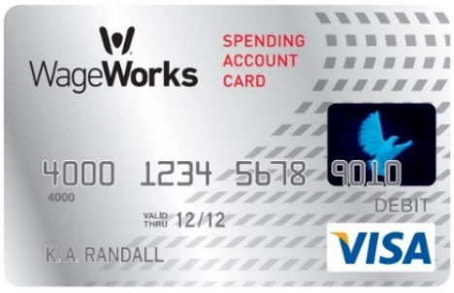

HealthEquity cards can be used with no personal identification number (PIN) or with a PIN. If you prefer to have a PIN for your card, you will have the option to create a PIN at the time of activating your new HealthEquity card.

Your current WageWorks debit card should continue to be used until the timeline indicated below:

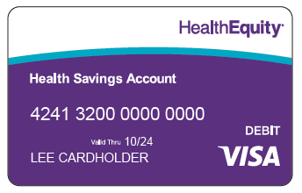
Health Savings Accounts
  - Your new HealthEquity HSA debit card will look similar to the image above and contain “424132” as the first 6 digits.

  - Your HSA will migrate on 12/16/2021. The last day to use your WageWorks card for HSA transactions is 12/7/2021. You should expect your new HealthEquity HSA debit card during the week of 11/29/2021.

  - When to use your HealthEquity debit card
    - For purchases you want paid from your HealthEquity HSA
      - IRS-qualified medical expenses
        - You will find a complete listing of IRS-qualified medical expenses at healthequity.com/learn/qualified-medical-expenses.

If you need a new WageWorks Healthcare Card, you may order a replacement card (or additional cards for your dependents) on the WageWorks platform or by calling 877.924.3967 (877.WageWorks).

We look forward to serving you.

Thank you,

HealthEquity Member Services

¹This card is issued by The Bancorp Bank: Member FDIC, pursuant to a license from Visa U.S.A. Inc. Your card can be used everywhere Visa debit cards are accepted for qualified expenses. This card cannot be used at ATMs and you cannot get cash back, and cannot be used at gas stations, restaurants, or other establishments not health related. See Cardholder Agreement for complete usage restrictions.
HealthEquity does not provide legal, tax or financial advice.

